Premier League 2016 Season Recap -- Arsenal Report Team

Summary:

This report looks at variety of players and clubs’ stats from our club and five to six major competitors, and gives several claims to the Board. The claims tend to find out the weakness of our club, to evaluate our players from the stats we gathered in recent several seasons, to find valuable players as our transfer targets, to discover the difference of our club and our major competitors’ behavior in seasons, so that we could strengthen ourselves in different aspects, or deeply understand rival and do preparation before a certain game. The data ranges from 2001 to 2016 season, from five different resources.

Part 1: Data Wrangling and Clean:

1. **Daily Game Result**

Website: http://www.football-data.co.uk/englandm.php

Description: Daily game result from season 2001 to 2016 (half, full time result, goals and

goal against)

Way to get and clean: Excel download and join together

**Tableau Database: Daily Game Result**

1. **Player Stats**

Website: <https://www.premierleague.com/stats>

Description: Top 60 players and all players from major clubs (Arsenal, Chelsea, Man City, Man Utd, Liverpool, Spurs and Eveton) in key performance stats (Shoots, Goals, Assists, Passes, Touches, Tackles, CleanSheets, Punches, Saves, Clearence, Big Chances Saved) from season 2010 to 2016.

Way to get and clean: Manual save to different Excel files, joined with **Player Value**, **Arsenal Player Wage** by Python.

**Tableau Database: EPL Player Stats(Big Club), Arsenal Player Stats**

1. **Player Value**

Website: [https://www.transfermarkt.co.uk/](https://www.transfermarkt.co.uk/manchester-united/startseite/verein/985/saison_id/2016)

Description: All players’ market value from major clubs (Arsenal, Man Utd, Man City, Spurs, Chelsea, Liverpool and Eveton) from 2010 to 2016

Way to get and clean: Python, downloaded html file, wrangled by beautiful soup, joined with **Player Stats**.

**Tableau Database: EPL Player Stats(Big Club)**

Issue: Some player name is different from other data sources, we use excel to match and clean before loading

1. **Club Record by Season**

Website: <http://www.espnfc.com/barclays-premier-league/23/table>

Description: League table from 2001 to 2016 (home and away records, goals, goal

against)

Way to get and clean: Python with beautiful soup

**Tableau Database: Club Record Yearly**

1. **Arsenal Player Wage**

Website: <http://sillyseason.com/salary/arsenal-players-salaries-69062/>

Description: Weekly wages of Arsenal players in 2017

Way to get and clean: Manual get to excel. Joined with **Arsenal Player Stats** by Python.

**Tableau Database: Arsenal Player Stats**

Critique of Data Wrangling and Clean:

Data Wrangling and clean took 70% even 80% time of the whole project. Several main issue to be noticed:

1. **Requirements change**. When making sheets in tableau, new ideas came out frequently to push finding new data. And you will find some data gathered is useless. So it’s better to do a precise requirement analysis from the claims before starting projects.
2. **Data Not Matching each other**. Data coming from different sources sometimes do not match, like player names. This problem is not easily to be recognized until figuring it out when making sheets by experience. Be careful when cleaning and joining the data, it’s better to use ETL tools.
3. **Heavily join on analysis tool (Tableau).** It would dramatically slow down the analysis tool and cause data matching problem. Beat ways is to join data as possible as in the cleaning tool (Python).

Part 2: Audience and Claims

Audience:

Our Board and Managers of the club. They want to read the Claim through Sheets and Dashboard to make decisions.

Claims 1:

Here is the table of **Top 20 players Market Value (below),** we think they are the most worth buying players in the next transfer window. If we have enough budget, we can pick best of the best, if not, we also have several wonderful choices in the lists.

Warrant:

Why those players? How we pick up them? Our team created a power ranking table of last season of all the players from major competitors: Chelsea, Man Utd, Man City, Liverpool, Spurs and Eveton. We use **Power Ranking Methodology (below)** which is referenced from Sky-Sports, and we think the methodology is better to evaluate a player than only considering some indicators like goals and assists. Here’s the original website we got the methodology: <http://www.skysports.com/football/news/11095/9994064/how-are-the-sky-sports-power-rankings-calculated>. Here’s the detail how we value our player:

Calculated Value = IF [Position1] == "Forward" THEN [Goals] * 1600 + [Assists] * 1100 + [Shots] * 150 + [Passes] * 2 + [Touches] * 1 + [Tackles] * 45 + [Clearance] * 50 + [Big Chances Missed] * (-300) ELSEIF [Position1] == "Midfielder" THEN [Goals] * 1800 + [Assists] * 1000 + [Shots] * 150 + [Passes] * 2 + [Touches] * 1 + [Tackles] * 55 + [Clearance] * 50 + [Big Chances Missed] * (-200) ELSE [Goals] * 2600 + [Assists] * 2000 + [Shots] * 150 + [Passes] * 2 + [Touches] * 1 + [Tackles] * 100 + [Clearance] * 75 + [Big Chances Missed] * (-200) END

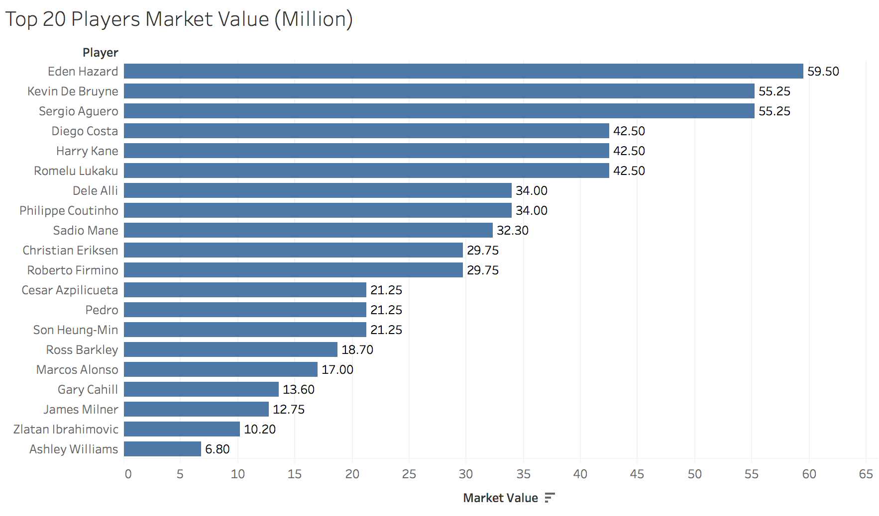

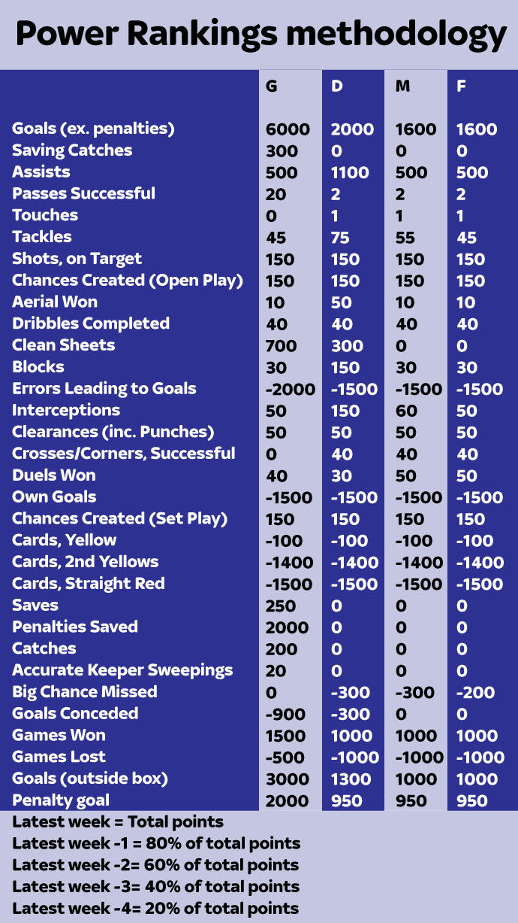

We doubled assists score from 500 to 1000 for Forward and Midfielder, and from 1100 to 2000 for Defender. We think assists is the next important stats to goals. We do not value goalkeepers here. You can see part of our **Power Ranking 2016 Report (below)**, if you are interested, we can give more detailed market value report on players other than top 20 from that power rankings report. Last, I would recommend some players as our targets for the summer transfer window: Sergio Aguero, Dele Alli, Pedro, Son-Heung Min, Ashely Williams.

**Sergio Aguero**: He’s 28 years old on his peek. Man City picked up Jesus as their first choice starter in the late of last season. Sergio may probably unhappy and leave the club if Man City does not guarantee him starter XI in the next season. Also, he’s very stable on his goals in last six seasons:

(Data coming from: <https://www.premierleague.com/players/4328/player/overview)>

Last, Bayern is targeting our super star-Alexis Sanchez, offering 50M Euros and doubled wages. If we lost him, Aguero is the perfect one to appear on our forward.

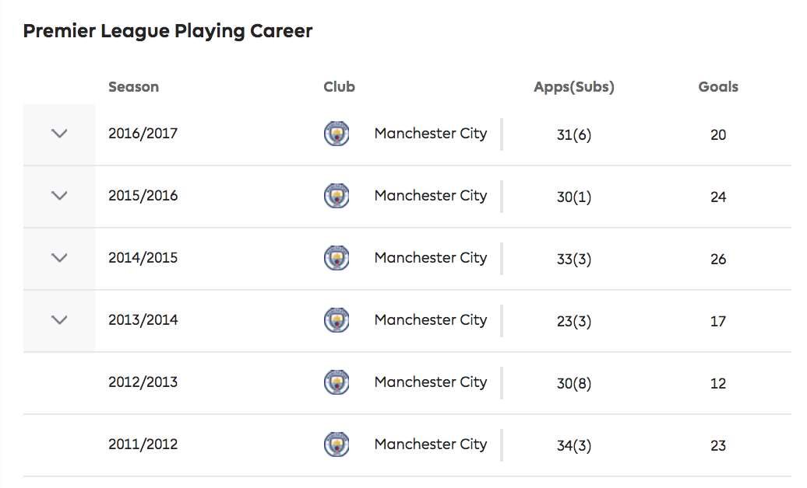

**Deli Alli**: He is only 21, but he is on the 3rd on our power rankings report. As a midfielder, he scored 18 goals which task is even hard for a forward. Besides, he values only 34M and probably become much more valuable in the near future. He’s potential is unpredictable as his age. Last, our Midfielder - Mezut Ozil has not decide to sign new contract since we cannot meet his highly wage demand. We could probably sell Ozil as his contact left less than 12 months. However, Alli is coming from our rival: Spurs. It would be difficult to sign the player.

If we do not have enough budgets, we could consider Pedro, Son and Ashely as our targets. Especially **Ashely Williams**, he scored very good in top 20 but his market value is only 6.8M. As our defender – Per Mertesacker is getting old, 32 years old, and suffered injury for almost whole last season. We could consider Ashely is a nice choice, but we still need to do a detail analysis on Ashely, since he got mostly his points from clearance. We’d better to evaluate if clearance is a KPI to judge a defender.

I would have to talk **Son-Heung-Min,** he is the only player who got monthly best player award twice last season.

Here’s part of our Power Ranking table for season 2016:

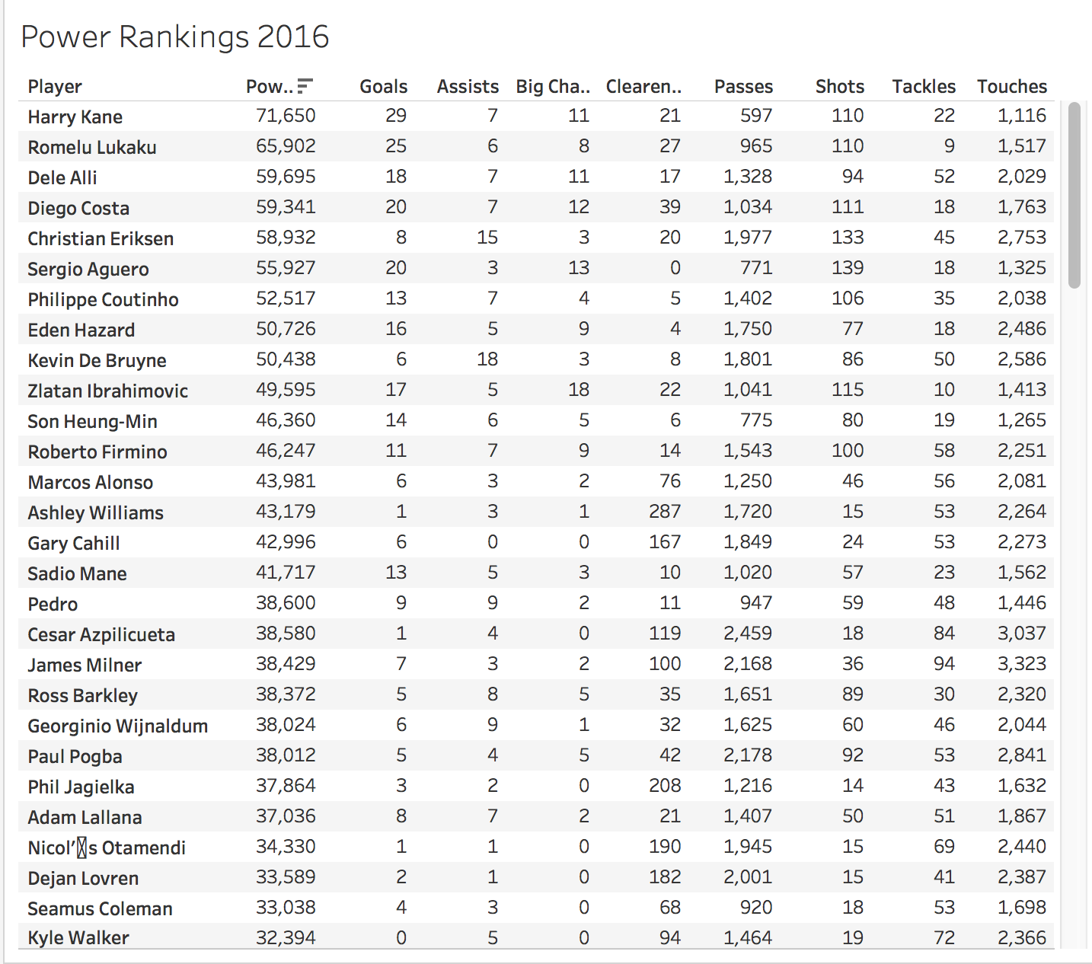

Claim 2:

I have some players to list from our club, also, we have some players who are invaluable to us.

Warrant:

How do we know? Here’s our **Players’ Minutes vs. Players’ Wages 2016** **(Below):**

**Bellerin, Koscielny and Moreal** are our best minutes/wages players. Their wages are not high, but they played a lot for us. While other players like **Lucas Perez and Debuchy** played less than 300 minutes and cost us over 60,000 a week. We could consider list those players. Jack Wilshere is the player on loan last season, he is also on high wage and we should evaluate his performance on his loaned club to make decision. **Alexis Sanchez and Mezut Ozil** are the two players who have already broken our salary system. If they keep asking doubled wages of their new contacts, the salary system would be even worse, and other players would probably complain their wages too. We recommend keep one of them and sell another if we have to give doubled wages. Here, we prepare another **Power Ranking Table (2014 – 2016)** **(below)** of our club. From that table, you can see Alexis did tremendous job: scored 1st and way beyond the 2nd, while Ozil is on the third, (they both joined from 2014). So we could consider list Ozil than Alexis if we have to. In meantime, Lucas Perez, Debuchy and Jack Wilshere is on the bottom of our table. Here’s a remind, be careful to look at the two tables: 1. some players are injured last season, **Minutes vs Wage** cannot very precisely reflects the truth: like Santiago Cazorla. But we could get information from **Power Ranking table**, that Cazola is on 6th rank overall. 2. some players like Xhaka, Mustafi are the new signings, they cannot behave well on **Power Ranking (2014 – 2016)**, which is the aggregate table. If you want, we could show you Power Ranking in one last season to get a precise answer. So it’s better to look different and more tables to get conclusion.

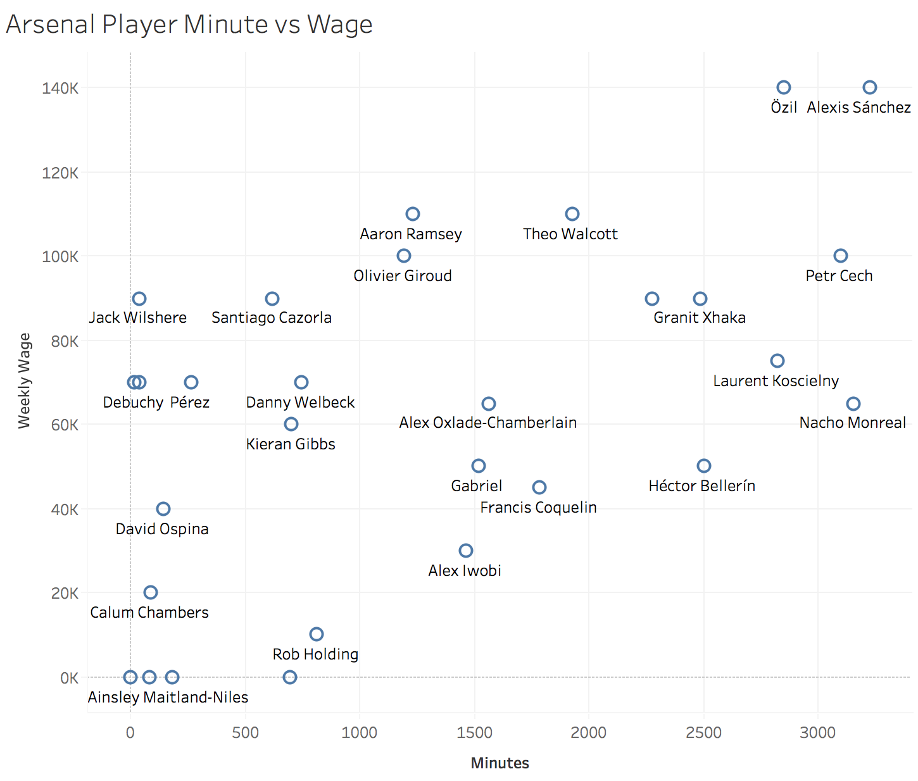

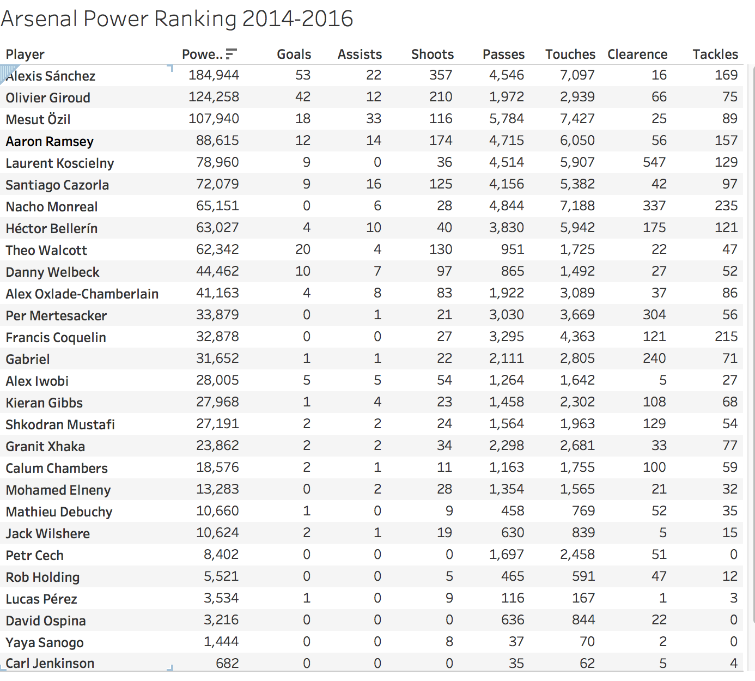

Claim 3:

Our record with major competitor is getting worse. **vs. Major Club Record (below)**

Our offense is getting worse compare to major competitors.

Our defense is stable, but we lost many goals on away games.

We need to do some specific trainings or tactics, or research feature of our rivals during seasons.

Warrant:

We picked up Chelsea, Liverpool, Man City, Man Utd and Spurs as major competitors. The winning% dropped a lot when playing against the major competitors since 2013, except Man United. If we only looked at 2016/17 season, we lost most of games to our competitors. In detail, if we look at our goals and goals against with competitors, **Goals vs. Major Rivals 2013-2016 (below),** we can figure out our offense was acceptable, but our defense was not. (Look at first line). We also could figure out some useful information: Liverpool, their offense was the best; Man United, their defense was the best, we should analyze their tactics toward major clubs.

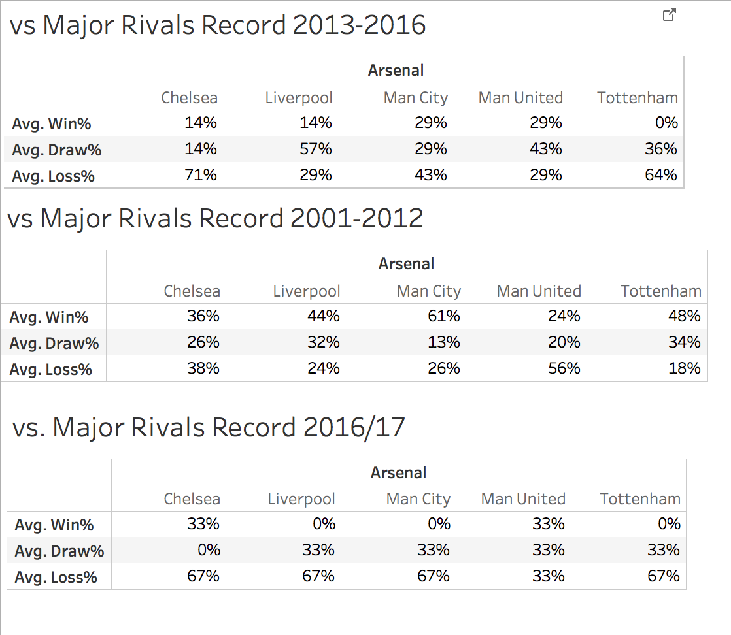

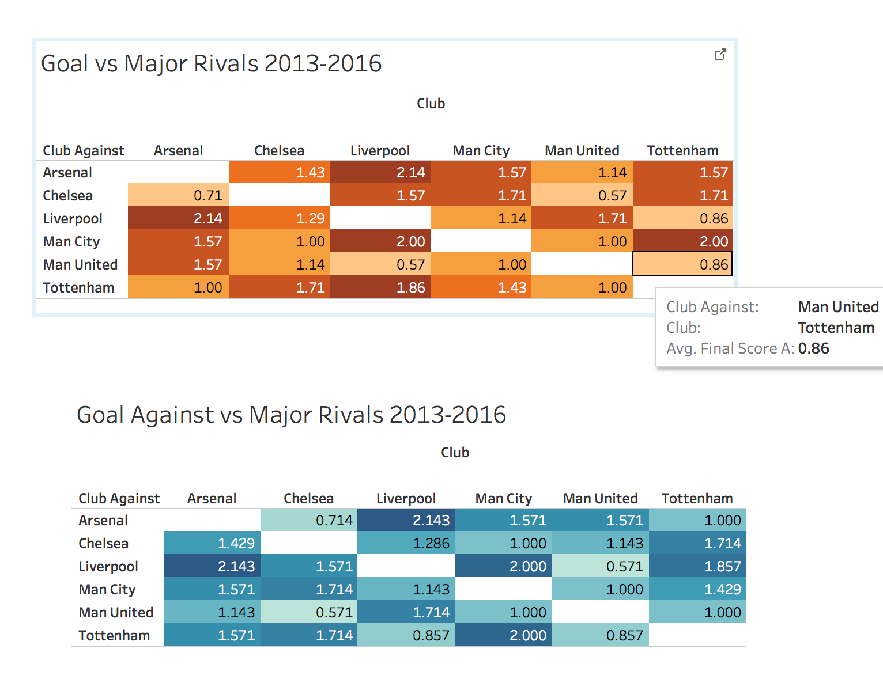

Our offense is getting worse if we compare different phrases. **Goal Rank Dashboard**

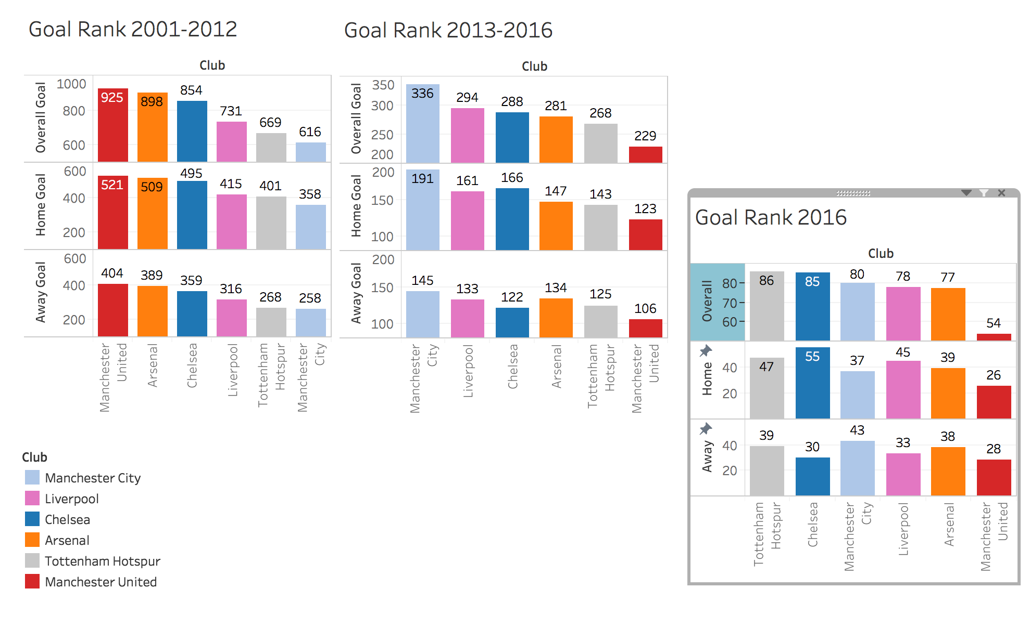

From season 2001 - 2012, our goal ranks 2nd, from season 2013 – 2016, rank dropped to 4th, last season, we dropped to 5th in all six major clubs. Besides, Chelsea, they scored much more in home games than away ones. In fact, we did good at away games, but Man City did better, we should be aware of it when we playing against them. Man United was lacking of goals last season, and since 2013, they became scoreless. They totally score We could adopt more offensive tactics when playing against them.

We are stable from 2001 - 2016 when we look at **Goal Against Dashboard (above).** But we did worst among six clubs in year 2016. Perhaps that’s why we rank 5th this season, the worst rank in recent 10 years. Our home record is good, but we lost many goals in our away games. We should do some detail analysis on our away games to reduce goals against.



An overview to our **Goals, Goals against and Winning% From 2001 - 2016**:

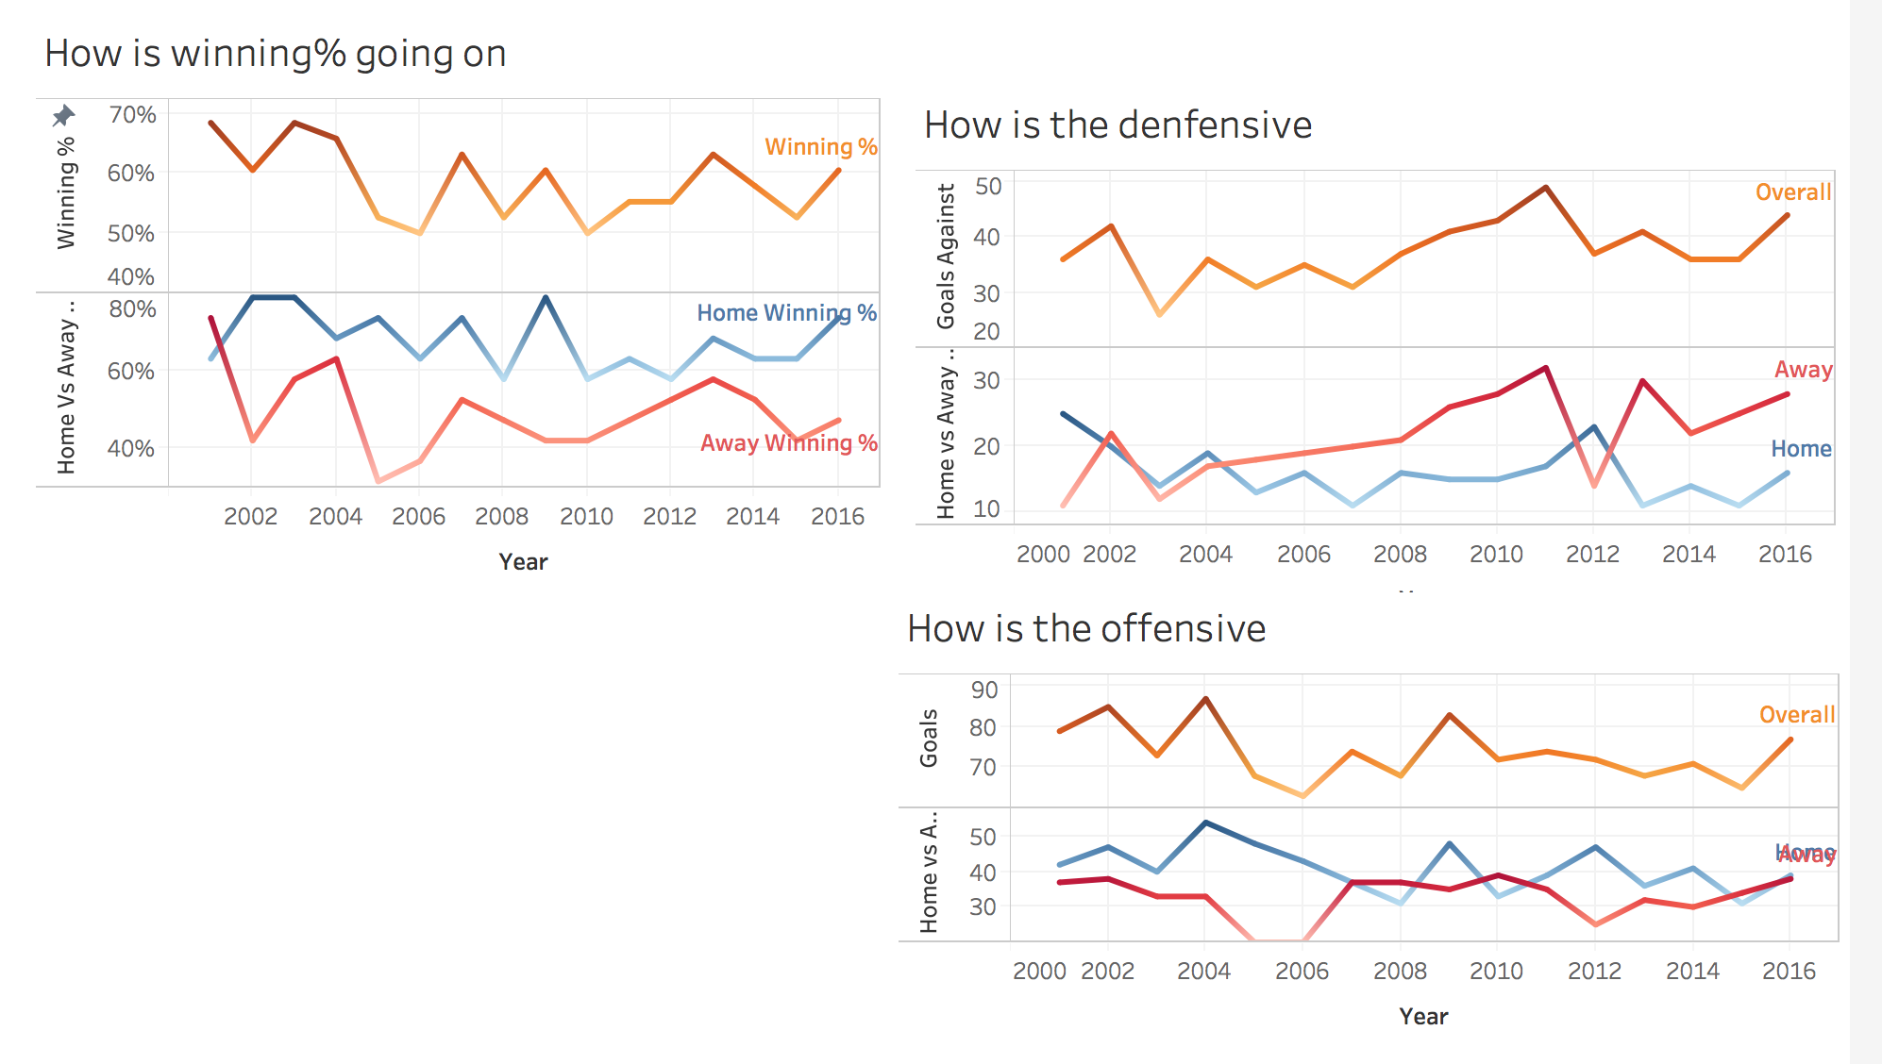

It just as we thought, our home record is much better than away ones, since we lost more goals at away games, and meantime our offense is stable at both home and away games. We need to figure out why our home defensive is much better than away ones.

Critique on Claims and Analysis:

1. **Be careful to choose chart and add multiple dimensions.** Charts sometimes could mislead audience, if the Axis number is not picked up well, especially when comparing two or more measurements: if you hide one header and leave another, and you changed range of axis which header is shown, you will easily forget to change another axis range because it is hidden, and your chart is wrong. Also, how long is the data? One year? Ten year? The result would be totally different. You have to clearly know what you are doing.
2. **Sheet is not always telling the truth.** You have to accept one sheet is not always right. You need to find out the “wrong” information. For example, injury players not reflect the truth when they are in the performance table. Then you should tell your audience some exception cases in order they would misunderstand your table.
3. **Use different sheet to verify points.** One sheet is not always right. Verify your point from different angles would be better to get your claim.

The End

There are several other sheets I did not mention here. You can review it from my workbook in github and give your feedback. Hope our club do better in the next season!

Github Link: https://github.com/folkeg/Arsenal-Report-2016-Season

Yuan Cheng

Arsenal Report Team

May 26th 2017